1. **What is software? What is software engineering?**

Software is a set of instructions, data or programs used to operate computers and execute specific tasks. It is the opposite of hardware, which describes the physical aspects of a computer. Software is a generic term used to refer to applications, scripts and programs that run on a device.

**Software engineering** is the branch of computer science that deals with the **design, development, testing, and maintenance of software applications.** Software engineers apply engineering principles and knowledge of programming languages to build software solutions for end users.

1. **Explain types of software**

**Application software:-**The most common type of software, application software is a computer software package that performs a specific function for a user, or in some cases, for another application. An application can be self-contained, or it can be a group of programs that run the application for the user. Examples of modern include office suites, graphics software, databases and database management programs, web browsers, word processors, software development tools, image editors and communication platforms.

**System software:-** These software programs are designed to run a computer's application programs and hardware. System software coordinates the activities and functions of the hardware and software. In addition, it controls the operations of the computer hardware and provides an environment or platform for all the other types of software to work in. The OS is the best example of system software; it manages all the other computer programs. Other examples of system software include the firmer, computer language translators and system utilizes.

**Driver software:-**Also known as device drivers, this software is often considered a type of system software. Device drivers control the devices and peripherals connected to a computer, enabling them to perform their specific tasks. Every device that is connected to a computer needs at least one device driver to function. Examples include software that comes with any nonstandard hardware, including special game controllers, as well as software that enables standard hardware, such as USB storage devices, keyboards, headphones, and printers.

**Middleware:-**The term *middleware* describes software that mediates between application and system software or between two different kinds of application software. For example, middleware enables Microsoft Windows to talk to Excel and Word. It is also used to send a remote work request from an application in a computer that has one kind of OS, to an application in a computer with a different OS. It also enables newer applications to work with legacy ones.

**Programming software:-** Computer programmers use programming software to write code. Programming software and programming tools enable developers to develop, write, test, and debug other software programs. Examples of programming software include assemblers, compilers, debuggers, and interpreters.

1. **What is SDLC? Explain each phase of SDLC**

The software development lifecycle (SDLC) is the cost-effective and time-efficient process that development teams use to design and build high-quality software. The goal of SDLC is to minimize project risks through forward planning so that software meets customer expectations during production and beyond. This methodology outlines a series of steps that divide the software development process into tasks you can assign, complete, and measure.

**1.To ensure that the software is of high quality:**The SDLC includes testing and quality assurance phases, which help to ensure that the software is free of bugs and that it meets the requirements.

**2.**[**To manage risks and costs:**](https://www.geeksforgeeks.org/software-risk-analysis/)The SDLC helps organizations to identify and manage risks early in the development process, which can help to reduce costs and minimize the impact of any issues that do arise.

**3.To improve communication and collaboration:**The SDLC helps to ensure that all stakeholders, including customers, end-users, and developers, are involved in the development process and that their needs are taken into account.

**4.To improve efficiency and productivity:**The SDLC helps organizations to optimize the use of resources and to streamline the development process, which can improve efficiency and productivity.

**5.To increase the likelihood of a successful project outcome:** Following a well-defined SDLC process can greatly increase the chances of success of the project, as the process guides the team towards the goal in a systematic and efficient way.

1. **What is DFD? Create a DFD diagram on Flipkart**

**DFD** is the abbreviation for **Data Flow Diagram**. The flow of data of a system or a process is represented by DFD. It also gives insight into the inputs and outputs of each entity and the process itself. DFD does not have control flow and no loops or decision rules are present. Specific operations depending on the type of data can be explained by a flowchart. It is a graphical tool, useful for communicating with users , managers and other personnel. it is useful for analyzing existing as well as proposed systems.

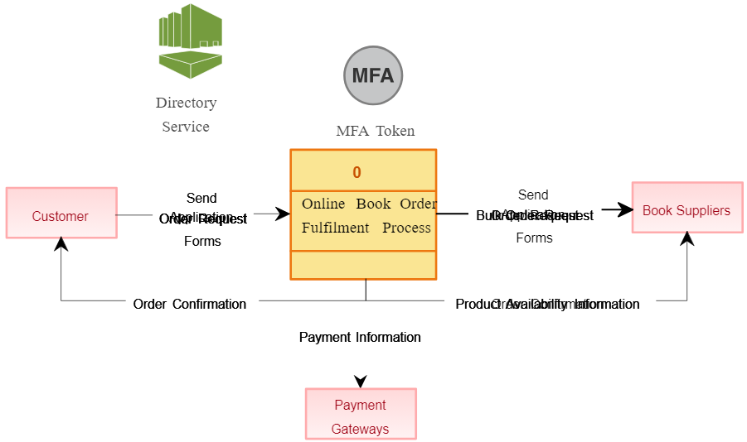

1. **What is Flow chart? Create a flowchart to make addition of two numbers**

A flowchart is a diagram that depicts a process, system or computer algorithm. They are widely used in multiple fields to document, study, plan, improve and communicate often complex processes in clear, easy-to-understand diagrams.

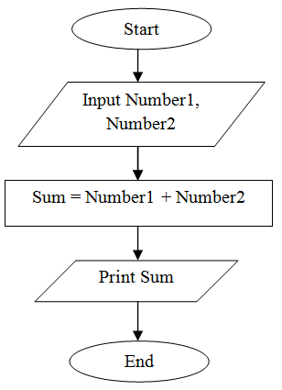

1. **What is Use case Diagram? Create a use-case on bill payment on paytm.**

A use case diagram is a way to summarize details of a system and the users within that system. It is generally shown as a graphic depiction of interactions among different elements in a system.

